Tutorial – 1

- Write a program to print “Hello World”.

namespace Tutorial___1
{
internal class T1
{
public static void t1()
{
Console.WriteLine("Hello, World!");
}
}
}

Output:
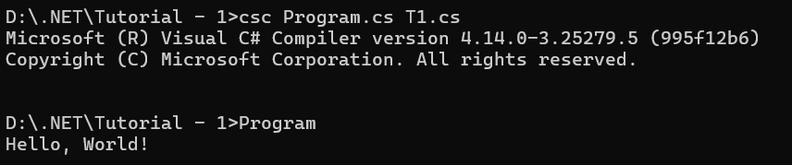

- Design your profile page as given below.

namespace Tutorial___1
{
internal class T2
{
public static void t2()
{
Console.WriteLine("$$ \nName : Hemal Rashiya\nDOB: 03/05/2006\nAddress: Ghughrala, Babra,\n \t Amreli" +
"\nCity: Rajkot\nPincode: 365410\nState: Gujrat\nCountry: India\nEmail: hrasiya212@ru.ac.in\n$$");
}
}
}

Output:
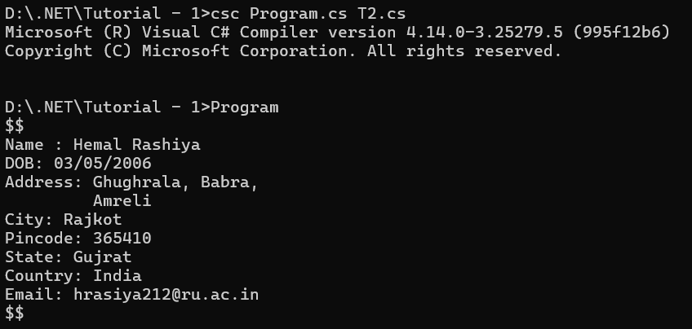

- Find out whether the given number is odd or even.
namespace Tutorial___1
{
internal class T3
{
public static void t3()
{
int n = 6;
if(n%2 == 0)
{
Console.WriteLine("n is even");
}
else
{
Console.WriteLine("n is odd");
}
}
}
}
Output:
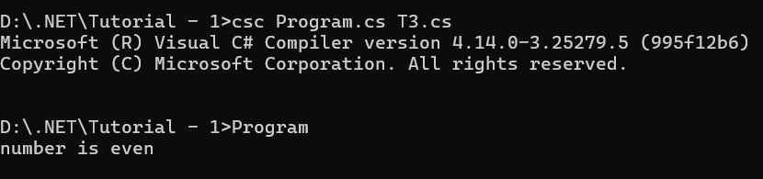
- Rearrange the given code to correct the program. The resultant program will be to input a number and print whether the given number is odd or even.
namespace Tutorial___1
{
internal class T4
{
public static void t4()
{
int x;
Console.WriteLine("Enter Number:");
String str = Console.ReadLine();
x = Convert.ToInt32(str);
if (x % 2 == 0)
{
Console.WriteLine("Number is Even");
}
else
{
Console.WriteLine("Number is Odd");
}
}
}
}
Output:
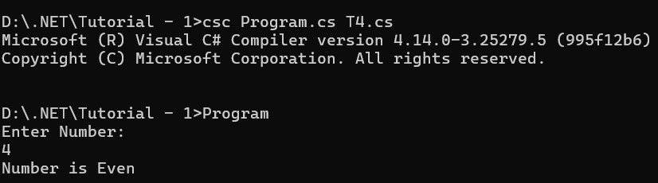
- Write output of the program. Also write comment for each line for the following code.
namespace Tutorial___1
{
internal class T5
{
public static void t5()
{
int n, fact = 1;
//Intialize the variable 'fact' to 1 and also intiaalize n.

Console.WriteLine("Enter Number : ");
//Print a statement 'enter number :' using writeline method.

string str = Console.ReadLine();
//Take a input from the user suing ReadLine method and store it in a string variable 'str'.
n = Convert.ToInt32(str);
//Convert str value into integer using Convert.ToInt32 method and stroe into n.

for (int i = 1; i <= n; i++)
//in for loop intialize i to 1 and check or run loop untill i is less than n.
{

fact = fact * i;
//Multiply the value of fact with i and store it in fact.

}

Console.WriteLine("Factorial : {0}", fact);
//Print a factorial value using WriteLine method.

Console.Read();
}
}
}
Output:
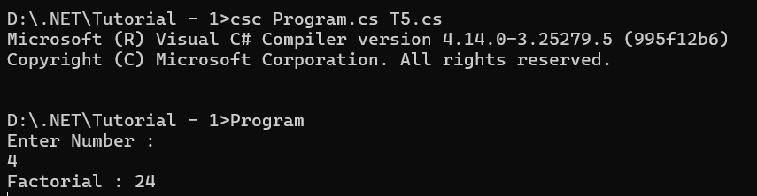
- Write missing statements to get the desired output.
namespace Tutorial___1
{
internal class T6
{
public static void t6()
{
int a, b, c, result;
Console.Write("Enter Number 1 : ");

String str = Console.ReadLine();
a = Convert.ToInt32(str);
Console.Write("Enter Number 2 : ");
str = Console.ReadLine();
b = Convert.ToInt32(str);
Console.Write("Enter Number 3 : ");
str = Console.ReadLine();
c = Convert.ToInt32(str);
result = Sum(a, b, c);
Console.WriteLine("Sum : "+result);
Console.Read();
}
static int Sum(int x, int y, int z)
{
int res;
res = x + y + z;
return res;
}
}
}
Output:
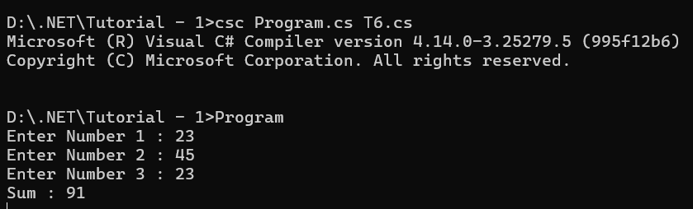
- Predict and write the output of the given code.
namespace Tutorial___1
{
internal class T7
{
public static void t7()
{
int num1, res, i;

Console.WriteLine("Enter a number");
num1 = Convert.ToInt32(Console.ReadLine());
i = 1; //Initialization
//Check whether condition matches or not
while (i <= 10)
{
res = num1 * i;
Console.WriteLine("{0} x {1} = {2}", num1, i, res);
i++; //Increment by one
}
Console.ReadLine();
}
}
}
Output:
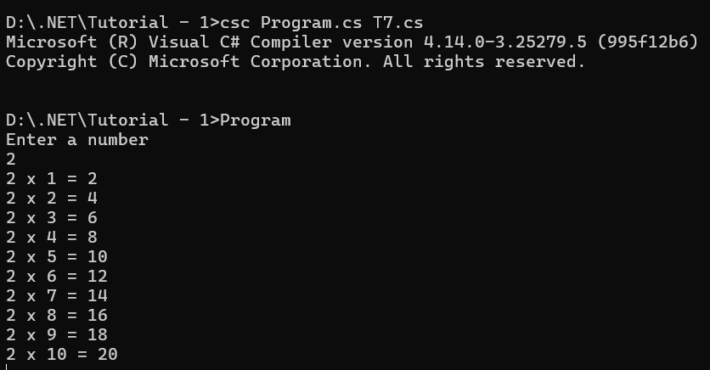
- Write a program to convert given name in upper characters.
namespace Tutorial___1
{
internal class T8
{
public static void t8()
{
Console.Write("INPUT : ");
String str = Console.ReadLine();
str = str.ToUpper();
Console.WriteLine("OUTPUT : " + str);

}
}
}
Output:
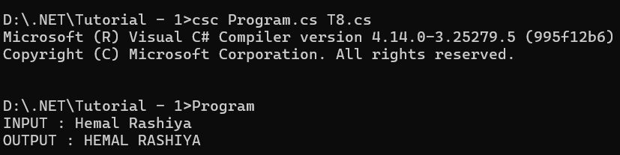
- Write a Program to convert given name in toggle case.
namespace Tutorial___1
{
internal class T9
{
public static void t9()
{
Console.Write("INPUT : ");
String str = Console.ReadLine();
String outputStr = "";
foreach (char c in str)
{
if (Char.IsUpper(c))
{
outputStr += Char.ToLower(c);
}
else
{
outputStr += Char.ToUpper(c);
}
}
Console.WriteLine("OUTPUT : " + outputStr);
}
}
}
Output:
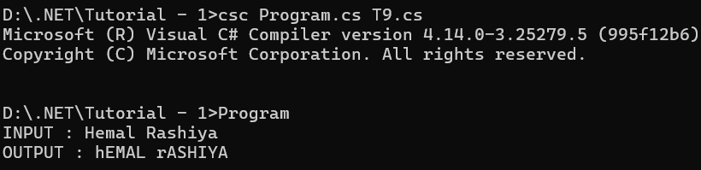
- Write a Program which accepts mobile no as a string from the user and converts the last 5 digits into X.
namespace Tutorial___1
{
internal class T10
{
public static void t10()
{
Console.Write("INPUT : ");
String input = Console.ReadLine();
for (int i = 1; i < input.Length; i++)
{
if (i <= 5)
{
Console.Write(input[i]);
}else
{
Console.Write("X");
}

}
}
}
}
Output:
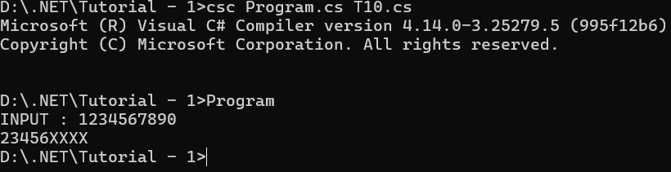

- Write a Program which accepts name and gender from the user. Here, gender may have only 1 character, M or F.
Based on the gender prefix the name Mr. & Ms.
namespace Tutorial___1
{
internal class T11
{
public static void t11()
{
Console.Write("NAME : ");
String name = Console.ReadLine();
Console.Write("\nGENDER : ");
char gender = Console.ReadKey().KeyChar;
if(gender == 'M')
{
Console.WriteLine("\nHello Mr. " + name);
}
else
{
Console.WriteLine("\nHello Ms. " + name);
}
}
}
}
Output:
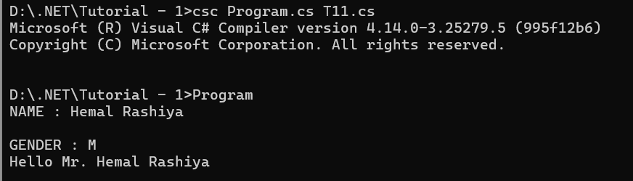
- Write a Program which accepts names from the user and prints the same
namespace Tutorial___1
{
internal class T12
{
public static void t12()
{
Console.Write("INPUT : ");
String str = Console.ReadLine();
Console.WriteLine("\nOUTPUT : "+str);
}
}
}
Output:
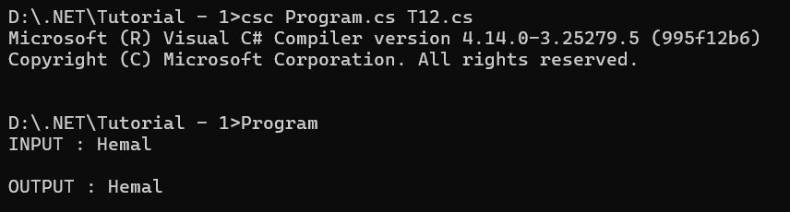
- Write a Program to print the following series
namespace Tutorial___1
{
internal class T13
{
public static void t13()
{
Console.Write("Enter number for fibonacci sereis : ");
String n = Console.ReadLine();

int a = 0, b = 1, c = 0,num;
num = Convert.ToInt32(n);
for(int i = 1; i <= num; i++)
{
c = a + b;
Console.Write(a + " ");
a = b;
b = c;
}

}
}
}
Output:
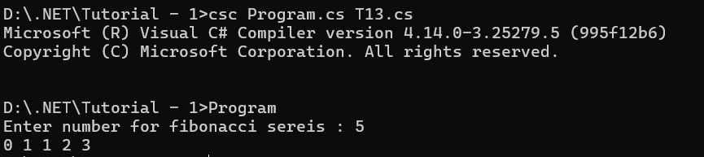
- Write a Program which accepts no from the user and print the same in words.
namespace Tutorial___1
{
internal class T14
{
public static void t14()
{
Array myArray = new String[10] { "Zero", "One", "Two", "Three", "Four","Five","Six","Seven","Eight","Nine" };
Console.Write("INPUT : ");
String str = Console.ReadLine();
foreach (char c in str)
{
switch (c)
{
case '0':
Console.Write("Zero ");
break;
case '1':
Console.Write("One ");
break;
case '2':
Console.Write("Two ");
break;
case '3':
Console.Write("Three");
break;
case '4':
Console.Write("Four ");
break;
case '5':
Console.Write("Five ");
break;
case '6':
Console.Write("Six ");
break;
case '7':
Console.Write("Seven ");
break;
case '8':
Console.Write("Eight ");
break;
case '9':
Console.Write("Nine ");
break;
}
}

}
}
}
Output:
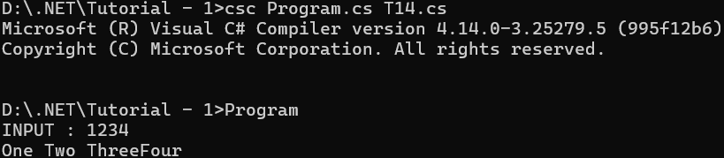
- Write a Program to check whether the given no is Armstrong no or not.
namespace Tutorial___1
{
internal class T15
{
public static void t15()
{
Console.Write("Enter a number: ");
int number = Convert.ToInt32(Console.ReadLine());

if (IsArmstrong(number))
{
Console.WriteLine($"{number} is an Armstrong number.");
}
else
{
Console.WriteLine($"{number} is not an Armstrong number.");
}
}

public static bool IsArmstrong(int number)
{
int originalNumber = number;
int sum = 0;
int numberOfDigits = 0;

// Calculate the number of digits
int tempNumber = number;
while (tempNumber > 0)
{
tempNumber /= 10;
numberOfDigits++;
}

// Calculate the sum of digits raised to the power of numberOfDigits
tempNumber = number; // Reset tempNumber to the original number
while (tempNumber > 0)
{
int digit = tempNumber % 10;
sum += (int)Math.Pow(digit, numberOfDigits);
tempNumber /= 10;
}

return sum == originalNumber;
}
}
}
Output:
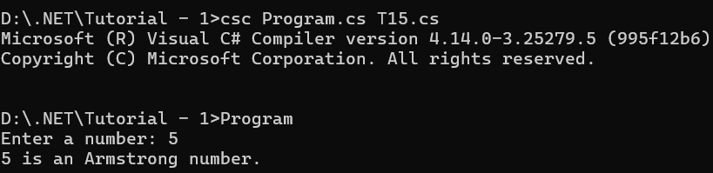
- Write a program to display a pattern like a right angle triangle using an asterisk
namespace Tutorial___1
{
internal class T16
{
public static void t16()
{
for(int i = 1; i <= 4; i++)
{
for(int j = 1; j <= i; j++)
{
Console.Write("* ");
}
Console.WriteLine();
}
}
}
}
Output:
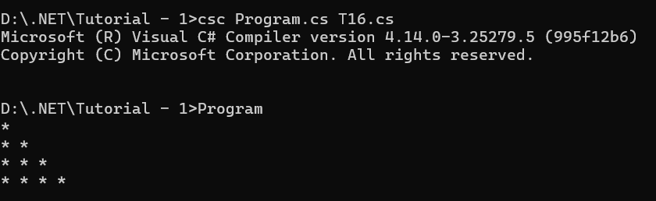
- Write a Program to generate following output.
namespace Tutorial___1
{
internal class T17
{
public static void t17()
{
for (int i = 1; i <= 4; i++)
{
for (int j = 1; j <= i; j++)
{
Console.Write(j + " ");
}
Console.WriteLine();
}
}
}
}
Output:
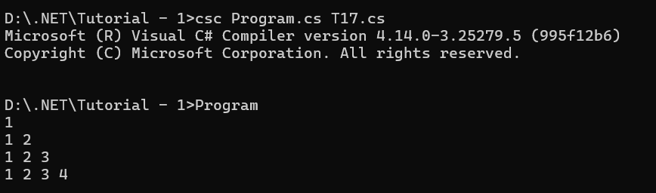
- Write a program to make such a pattern like a right-angle triangle with the number increased by 1.

namespace Tutorial___1
{
internal class T18
{

public static void t18()
{
int n = 1;
for (int i = 1; i <= 4; i++)
{
for (int j = 1; j <= i; j++)
{
Console.Write(n + " ");
n++;
}
Console.WriteLine();
}
}
}
}
Output:
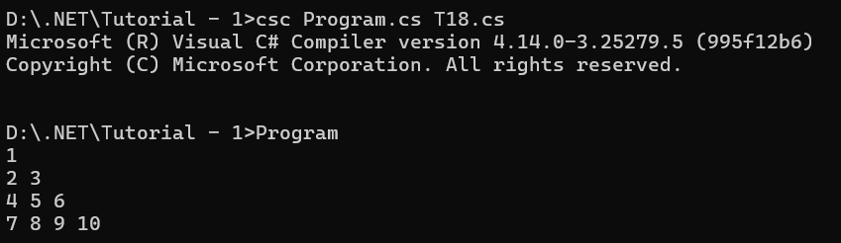
- Write a program to make such a pattern as a pyramid with an asterisk.
namespace Tutorial___1
{
internal class T19
{
public static void t19()
{
int rows = 4;

for (int i = 1; i <= rows; i++)
{

for (int j = 1; j <= rows - i; j++)
{
Console.Write(" ");
}

for (int k = 1; k <= i; k++)
{
Console.Write("* "); // Asterisk followed by a space
}
Console.WriteLine(); // Move to the next line after each row
}
}
}
}
Output:
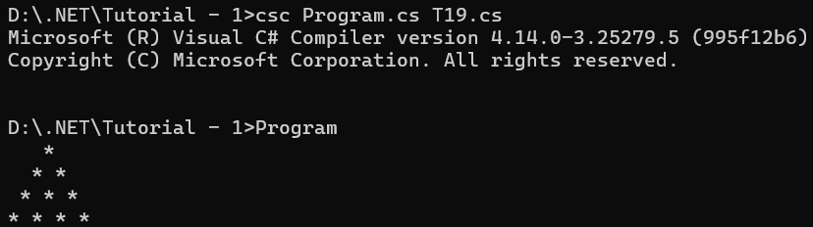
- Write a program to make a pyramid pattern with numbers increased by 1.
namespace Tutorial___1
{
internal class T20
{
public static void t20()
{
int rows = 4, n = 1;

for (int i = 1; i <= rows; i++)
{

for (int j = 1; j <= rows - i; j++)
{
Console.Write(" ");
}

for (int k = 1; k <= i; k++)
{
Console.Write(n + " "); // Asterisk followed by a space
n++;
}
Console.WriteLine(); // Move to the next line after each row
}
}
}
}
Output:
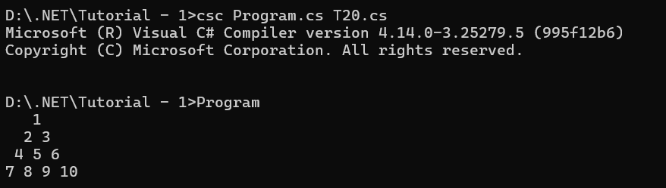
- Write a program to find the sum of the series 5 +55 + 555 + 5555 + .. n terms.
namespace Tutorial___1
{
internal class T21
{
public static void t21()
{
Console.WriteLine("Input the number of terms : ");
String terms = Console.ReadLine();
Console.WriteLine("Input number : ");
String number = Console.ReadLine();
int ans = 0, num = 0,total = 0;
num = Convert.ToInt32(number);
for (int i = 1; i <= Convert.ToInt32(terms); i++)
{
ans = (ans * 10) +num;
total += ans;
Console.Write(ans + " + ");
}
Console.WriteLine("The sum is : " + total);
}
}
}
Output:
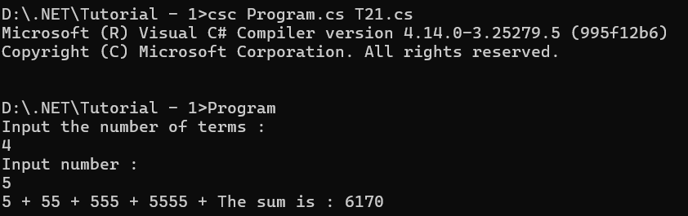
- Write a program to display a pattern like a diamond.
namespace Tutorial___1
{
internal class T22
{
public static void t22()
{
int rows = 4;

for (int i = 1; i <= rows; i++)
{

for (int j = 1; j <= rows - i; j++)
{
Console.Write(" ");
}

for (int k = 1; k <= i; k++)
{
Console.Write("* "); // Asterisk followed by a space
}
Console.WriteLine(); // Move to the next line after each row
}

for (int i = 4; i >= 0; i--)
{

for (int j = 1; j <= rows - i; j++)
{
Console.Write(" ");
}

for (int k = 1; k <= i ; k++)
{
Console.Write("* "); // Asterisk followed by a space
}
Console.WriteLine(); // Move to the next line after each row
}

}
}
}
Output:

